**www.als-journal.com/ ISSN 2310-5380/ May 2025**



Full Length Research Article

Advancements in Life Sciences – International Quarterly Journal of Biological Sciences

ARTICLE INFO

Date Received:

20/10/2024;

Date Revised:   
05/01/2025;

Available Online: 22/03/2025;

**Author’s Affiliation:**

Department of Medical Laboratory Technology, College of Nursing and Health Sciences, Jazan University – Saudi Arabia 

**\*Corresponding Author:**

Fatemah Abdulaziz Alhakami

Email:

[falhakami@jazanu.edu.sa](mbioph@abv.bg) 

**How to Cite:**

Alhakami FA (2025). Targeting BCL-2 in Hematological Cancers: Computational Screening of Cucurbitacins as Promising Inhibitors.Adv. Life Sci. 12(2): 312-316.



**Keywords:**

Cancer; Apoptosis; BCL-2; Cucurbitacin compounds; Druglikeness  

http://www.fzt.haw-hamburg.de/pers/Scholz/aast/logoIndexed-In-DOAJ.jpg

Open Access



Targeting BCL-2 in Hematological Cancers: Computational Screening of Cucurbitacins as Promising Inhibitors

Fatemah Abdulaziz Alhakami*

Abstract

B

**ackground:** Disrupting the balance between cell proliferation and death is critical in cancer formation. Increased resistance to apoptosis, which is frequently caused by BCL-2 overexpression, is a critical oncogenic mechanism in many hematologic malignancies, notably lymphoid neoplasias. Overexpression of anti-apoptotic BCL-2 proteins is frequent in many malignancies, prompting the development of BCL-2 inhibitors as therapeutic agents.

**Methods:** In this study, 28 cucurbitacin compounds were screened against BCL-2 using insilico PyRx tool to find strong natural inhibitors for treating hematological malignancies. ADMET-AI web interface was used to analyze ADMET properties of hit compounds.

**Results:** Cucurbitacin O, IIb, K, and H were effective BCL-2 inhibitors, with binding energies ranging from -8.0 to -8.8 kcal/mol, similar to the control compound (-7.9 kcal/mol). These compounds interacted with key amino acid residues in BCL-2. The radial graphs show that all four compounds have good ADMET characteristics. The compounds have a high probability of being safe for the blood-brain barrier and pose a low risk of hERG channel blockage. Furthermore, they have higher oral bioavailability and adequate water solubility. Their minimal clinical toxicity profiles indicate their potential safety in therapeutic applications.

**Conclusion:** Cucurbitacin O, IIb, K, and H can be employed as BCL-2 inhibitors to manage hematological malignancies. However, further experimental studies are needed to validate these compounds as BCL-2 inhibitors.

Introduction

Apoptosis, a highly controlled type of programmed cell death, is required for processes such as organ formation, immunological modulation, and the elimination of diseased, altered, or damaged cells [1]. In an average human adult, apoptosis occurs in 50 to 70 billion cells each day. Dysregulation of apoptosis is a hallmark of cancer, contributing to the buildup of neoplastic cells by lowering cell turnover [2]. Despite their various architectures, many chemotherapy medicines activate apoptotic pathways to kill cancer cells [3]. Therefore, restoring apoptosis is a vital technique in cancer prevention and treatment. The suppression of apoptosis promotes uncontrolled growth and adds to the accumulation of oncogenic mutations. Significant advances in cancer research have revealed the apoptotic machinery and its relationship to altered protein expression in malignancies [4]. The B-cell lymphoma-2 (BCL-2) family controls apoptosis in response to stress signals [5]. Enhanced levels of anti-apoptotic proteins BCL-2 and BCL-XL have been associated with tumor development and treatment resistance [6, 7]. BCL-2, the first gene identified as promoting cell survival rather than growth [8], emphasizes the importance of apoptosis inhibition in cancer [5]. BCL-2 inhibitors and BH3-mimetics have shown potential therapeutic results, particularly in the treatment of lymphoid malignancies with enhanced BCL-2 levels [9, 10]. Drug development seeks to identify small synthetic chemicals or large macromolecules that can be examined as potential therapeutic possibilities. This method, which takes several years [11, 12], is divided into various stages: discovering therapeutic targets, identifying hits to leads, optimizing leads, and conducting preclinical and clinical studies. Computer-assisted drug discovery (CADD) techniques have accelerated the process while decreasing costs and late-stage failure rates. CADD includes both structure- and ligand-based techniques [13,14]. The purpose of this study is to identify natural BCL-2 inhibitors from Cucurbitacin compounds utilizing various computational techniques such as structure-based virtual screening (VS) and ADMET prediction.

Methods

**Protein preparation**

The 3D structure of BCL-2 (PDB ID: 6GL8) was obtained from the PDB database [15]. The BCL-2 PDB structure was in complex with the inhibitor S55746, also known as BCL201, and has been removed. The resulting protein structure was saved in the .pdb format. The Chimera software suite minimized the structure, which began with 100 steps of steepest descent minimization and then ten steps of conjugate gradient minimization. The prepared protein structure was saved as pdb for VS.

**Cucurbitacin compounds retrieval and preparation**

The PubChem database has been employed to obtain 28 compounds from the Cucurbitacin family for VS. The compounds were identified through a comprehensive search for known Cucurbitacins using PubChem's compound search feature. The chemical structures were obtained in SDF format and subsequently converted into 3D coordinates for docking applications. The structures were energy-minimized using the MMFF94 force field to ensure accurate geometry and subsequently transformed to pdbqt format with the PyRx tool before molecular docking-based VS.

**Molecular docking based virtual screening**

The rapid expansion of chemical libraries to over a billion molecules has increased the demand for more efficient VS methods. VS, which uses computational tools to predict bioactive compounds from large libraries of small molecules, is gaining traction in drug discovery. As insilico techniques improve and become more widely available, private and public organizations increasingly use VS to conserve laboratory resources [16]. PyRx tools was employed to screen the cucurbitacin compounds against the BCL2 active site [17]. The XYZ coordinates of the structure were determined to be 15.966811, 2.049132, and 16.196132, respectively.

**ADMET Prediction**

The top four hits were analyzed for ADMET attributes and physicochemical features via the ADMET-AI online interface. The machine learning tool ADMET-AI used prediction algorithms to determine ADMET attributes and important physicochemical features. The predictions covered gastrointestinal absorption, blood-brain barrier permeability, CYP450 interactions, half-life, clearance, and toxicity profiles such as hepatotoxicity and cardiotoxicity [18].

Results

In this study, 28 cucurbitacin compounds were screened against BCL2 to find effective natural BCL2 inhibitors. Targeting BCL2 is a viable therapeutic option since it regulates apoptosis and is an important factor in the progression and survival of hematological malignancies. The structural examination of BCL2 found that its PDB structure was unsatisfactory. The missing regions were modeled were modeled with the Swiss Model tool (with PDB ID: 6GL8 as the template). The modeled structure was energy minimized and then prepared for screening against a library of 28 cucurbitacin compounds (figure 1). Furthermore, the bound inhibitor BCL201 was used as a positive control in the screening process to assess the inhibitory efficacy of the cucurbitacin compounds.

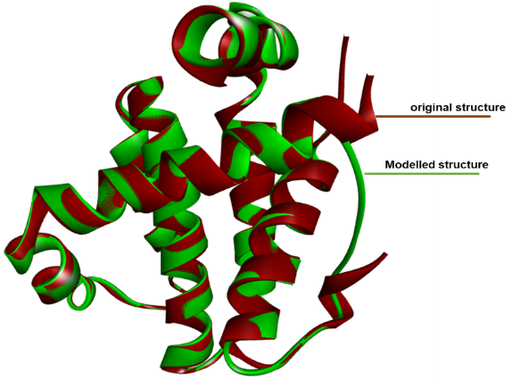

**Figure 1:** Superimposed view of the modeled BCL-2 protein structure (green) and the original experimental structure (red), illustrating the structural alignment and conformational similarities.

|  |  |  |
| --- | --- | --- |
| **S. No.** | **Ligand** | **Binding affinity (kcal/mol)** |
|  | Cucurbitacin O | -8.8 |
|  | Cucurbitacin IIb | -8.5 |
|  | Cucurbitacin K | -8.3 |
|  | Cucurbitacin H | -8 |
|  | Cucurbitacin S 2-glucoside | -7.5 |
|  | Cucurbitacin I | -7.5 |
|  | Cucurbitacin IIa | -7.3 |
|  | Cucurbitacin I | -7.3 |
|  | Cucurbitacin I 2-O-beta-D-glucopyranoside | -7.3 |
|  | Cucurbitacin BE | -7.3 |
|  | Cucurbitacin U | -7.1 |
|  | Cucurbitacin B | -7.1 |
|  | Cucurbitacin D | -7.1 |
|  | Cucurbitacin V gentobioside | -7 |
|  | Cucurbitacin S | -7 |
|  | Cucurbitacin R 2,25-diglucoside | -7 |
|  | Cucurbitacin J | -7 |
|  | Cucurbitacin F | -7 |
|  | Cucurbitacin L | -6.9 |
|  | Cucurbitacin P | -6.9 |
|  | Cucurbitacin U gentobioside | -6.8 |
|  | Cucurbitacin A | -6.8 |
|  | Cucurbitacin E | -6.5 |
|  | Cucurbitacin Q | -6.5 |
|  | Cucurbitacin-L-2-O-beta-D-glucopyranoside | -6.3 |
|  | Cucurbitacin C | -6.3 |
|  | Cucurbitacin Q1 | -6.2 |
|  | Cucurbitacin D 2,16,25-triacetate | -6.1 |
|  | Positive control (BCL201) | -7.9 |

**Table 1:** Screened 28 cucurbitacins compounds along with positive control (BCL201) and their binding affinity values.

This study used BCL201 as a positive control to assess the inhibitory efficacy of the screened cucurbitacin compounds. The comparison of BCL201 to the top four candidates from the screening analysis revealed significant insights into the efficacy of the cucurbitacin compounds, which had similar interactions with the BCL2 active site, indicating their potential as BCL-2 inhibitors for hematological malignancies. The VS study identified Cucurbitacin O, IIb, K, and H as potent BCL-2 inhibitors, with binding energies ranging from -8.0 to -8.8 kcal/mol, comparable to the control (-7.9 kcal/mol). Cucurbitacin O demonstrated the strongest binding affinity (-8.8 kcal/mol), suggesting a highly stable interaction with the BCL2 binding pocket (Table 1).

Cucurbitacin IIb was found to interact with Asn84, Gly86, Arg87, Ala90, Phe45, Leu78, Val74, Gln59, Glu55, Asp52, Met56, Phe53, and Tyr49 residues of BCL-2 (Figure 2). Cucurbitacin K bind with Arg87, Leu60, Glu77, Val74, Phe94, Gln59, Met56, Glu55, Asp52, Phe53, Ala90, Phe45, Tyr49, and Leu78 residues of BCL-2 (Figure 2). Cucurbitacin O interacted with Phe53, Met56, Phe94, Ala90, Val74, Leu78, Tyr49, Phe45, Arg87, Val89, Gly86, Tyr143, and Arg48 residues of BCL-2 protein (Figure 2); while Met56, Phe53, Phe94, Leu78, Ala90, Phe45, Arg87, Arg48, Val89, Gly86, and Tyr49 residues of BCL-2 were interacted with Cucurbitacin H (Figure 2). Further, the control compound was found to bind with Ala90, Phe45, Arg87, Val74, Tyr49, Glu77, Phe53, Asp52, Glu55, Met56, Gln59, Leu78, and Phe94 residues of BCL-2 protein (Figure 2).

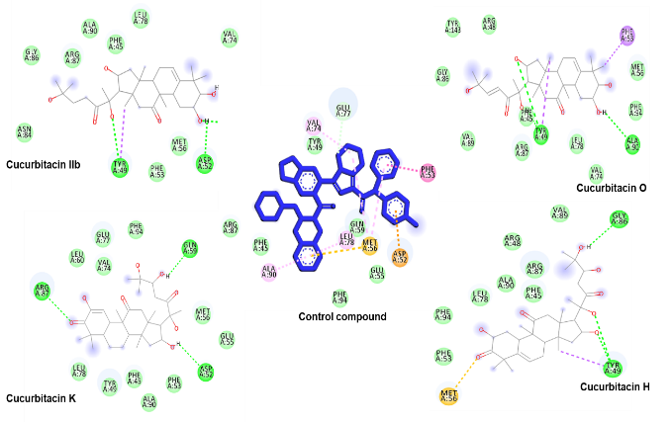

**Figure 2:** 2D interaction diagrams of the top four hit compounds and the control compound (BCL201) with the active site residues of the BCL-2 protein, illustrating key interactions.

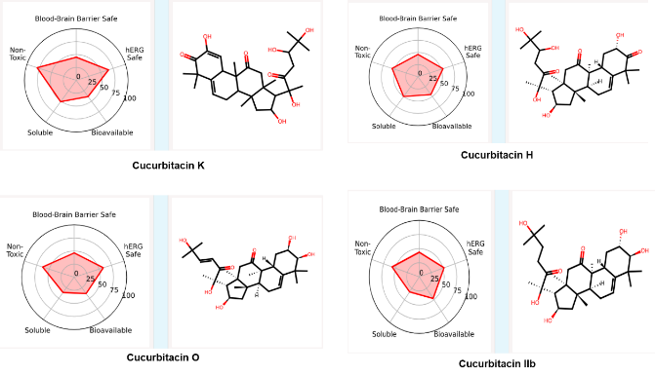**Figure 3:** Radial plots of the top four hit compounds summarizing five key ADMET properties: blood-brain barrier safety, hERG safety, bioavailability, solubility, and non-toxicity, compared to the DrugBank reference set.

The assessment of ADMET predictions for the top four hits extensively evaluates five essential pharmacokinetic and toxicity attributes: safety related to the blood-brain barrier, safety concerning the hERG channel, bioavailability, solubility, and non-toxicity. The radial plots indicate that all four compounds demonstrate favorable ADMET profiles relative to the DrugBank reference set. The compounds exhibit a considerable probability of being safe for the blood-brain barrier and pose minimal risk of hERG channel blockade, suggesting a diminished likelihood of cardiotoxicity. Furthermore, they exhibit increased oral bioavailability and sufficient aqueous solubility, which are critical for optimal absorption and distribution. Their low clinical toxicity profiles highlight their potential safety in therapeutic uses (Figure 3).

Discussion

The BCL-2 family controls apoptosis in response to environmental and stress signals. Increased levels of anti-apoptotic proteins like BCL-2 and BCL-XL are associated with tumor initiation, progression, and treatment resistance [6,7]. In this study, 28 cucurbitacin compounds were screened against BCL-2 to find potent natural inhibitors for treating hematological malignancies. The screening analysis found Cucurbitacin O, IIb, K, and H as effective BCL-2 inhibitors with higher binding energies than the control compound.

BCL201 was used as a positive control to determine the inhibitory efficacy of the screened cucurbitacin compounds. BCL201 is a selective BCL-2 inhibitor with high pro-apoptosis characteristics [19]. BCL201 was interacted with Ala90, Phe45, Arg87, Val74, Tyr49, Glu77, Phe53, Asp52, Glu55, Met56, Gln59, Leu78, and Phe94 residues of BCL-2. Accordingly, Cucurbitacin O, IIb, K, and H were found to bind with these BCL-2 residues.

Hydrogen bonding has a vital role in the stability of compound-protein complexes [20-24]. Cucurbitacin O, IIb, K, and H were observed to make H-bonds with the amino acid residues of BCl-2. Cucurbitacin IIb makes hydrogen bond with Tyr49 and Asp52 residues of BCL-2, whereas Cucurbitacin O makes the hydrogen bond with Tyr49 and Ala90 residues. Cucurbitacin K makes hydrogen bond with Arg87 and Gln59 BCL-2 residues. Cucurbitacin H also makes hydrogen bond with the Gly86 and Tyr49 BCL-2 residues.

Cucurbitacins, a highly oxygenated triterpene, are popular due to their potent anticancer effects [25, 26]. These chemicals have a variety of biological functions [25, 27]. Cucurbitacins have been found to induce apoptosis, inhibit cell growth, and disrupt important signaling pathways [28]. Their ability to modulate these critical pathways makes them promising candidates for cancer therapy. Furthermore, research has indicated that cucurbitacins can make cancer cells more responsive to chemotherapy, hence increasing treatment efficacy [29]. Cucurbitacins' characteristics make them useful natural substances for the development of novel cancer therapies.

Increased levels of anti-apoptotic proteins such as BCL-2 have been associated with tumor development and treatment resistance. This study screened 28 cucurbitacin compounds against BCL-2 in order to identify possible natural BCL-2 inhibitors for treating hematological malignancies. Cucurbitacin O, IIb, K, and H were found as strong BCL-2 inhibitors, with binding energies greater than the control BCL201. In addition, these compounds demonstrate favorable ADMET profiles. Hence, these compounds can be used as BCL-2 inhibitors to manage hematological malignancies.

References

1. Reed JC. Apoptosis-based therapies. Nature Reviews Drug Discovery, (2002); 1(2): 111-121.
2. Hanahan D, Weinberg RA. Hallmarks of cancer: the next generation. Cell, (2011); 144(5): 646-674.
3. Hannun YA. Apoptosis and the dilemma of cancer chemotherapy. Blood, (1997); 89(6): 1845-1853.
4. Hainaut P, Plymoth A. Targeting the hallmarks of cancer: towards a rational approach to next-generation cancer therapy. Current Opinion in Oncology, (2013); 25(1): 50-51.
5. Arici R, Kemal AK, Pabuccuoğlu S, Birler S, Demir K, et al. Effects of melatonin addition to the cold storage medium on cumulus oocyte complex apoptosis, viability and in vitro maturation rates of cat oocytes. Kafkas Üniversitesi Veteriner Fakültesi Dergisi. (2022) ; 28(2): 193-200.
6. Tsujimoto Y, Gorham J, Cossman J, Jaffe E, Croce CM. The t(14;18) chromosome translocations involved in B-cell neoplasms result from mistakes in VDJ joining. Science, (1985); 229(4720): 1390-1393.
7. Lessene G, Czabotar PE, Colman PM. BCL-2 family antagonists for cancer therapy. Nature Reviews Drug Discovery, (2008); 7(12): 989-1000.
8. Vaux DL, Cory S, Adams JM. Bcl-2 gene promotes haemopoietic cell survival and cooperates with c-myc to immortalize pre-B cells. Nature, (1988); 335(6189): 440-442.
9. Roberts AW, Huang D. Targeting BCL2 With BH3 Mimetics: Basic Science and Clinical Application of Venetoclax in Chronic Lymphocytic Leukemia and Related B Cell Malignancies. Clinical Pharmacology & Therapeutics, (2017); 101(1): 89-98.
10. Billard C. BH3 mimetics: status of the field and new developments. Molecular Cancer Therapeutics, (2013); 12(9): 1691-1700.
11. Marti-Renom MA, Stuart AC, Fiser A, Sanchez R, Melo F, Sali A. Comparative protein structure modeling of genes and genomes. Annual Review of Biophysics and Biomolecular Structure, (2000); 29: 291-325.
12. Pfisterer JHK, Liang Y, Schneider O, Bandarenka AS. Direct instrumental identification of catalytically active surface sites. Nature, (2017); 549(7670): 74-77.
13. Gu R, Wu F, Huang Z. Role of Computer-Aided Drug Design in Drug Development. Molecules, (2023); 28(20): 7160.
14. Yu W, MacKerell AD, Jr. Computer-Aided Drug Design Methods. Methods in Molecular Biology, (2017); 1520: 85-106.
15. Casara P, Davidson J, Claperon A, Le Toumelin-Braizat G, Vogler M, et al. S55746 is a novel orally active BCL-2 selective and potent inhibitor that impairs hematological tumor growth. Oncotarget, (2018); 9(28): 20075-20088.
16. Gimeno A, Ojeda-Montes MJ, Tomas-Hernandez S, Cereto-Massague A, Beltran-Debon R, et al. The Light and Dark Sides of Virtual Screening: What Is There to Know? International Journal of Molecular Sciences, (2019); 20(6): 1375.
17. Dallakyan S, Olson AJ. Small-molecule library screening by docking with PyRx. Methods in Molecular Biology, (2015); 1263: 243-250.
18. Swanson K, Walther P, Leitz J, Mukherjee S, Wu JC, et al. ADMET-AI: a machine learning ADMET platform for evaluation of large-scale chemical libraries. Bioinformatics, (2024); 40(7): btae416.
19. Yang S, Mao Y, Zhang H, Xu Y, An J, Huang Z. The chemical biology of apoptosis: Revisited after 17 years. European Journal of Medicinal Chemistry, (2019); 177: 63-75.
20. Sait KHW, Alam Q, Anfinan N, Al-Ghamdi O, Malik A, et al. Structure-based virtual screening and molecular docking for the identification of potential novel EGFRkinase inhibitors against ovarian cancer. Bioinformation, (2019); 15(4): 287-294.
21. Nazam N, Lone MI, Hamid A, Qadah T, Banjar A, et al. Dimethoate Induces DNA Damage and Mitochondrial Dysfunction Triggering Apoptosis in Rat Bone-Marrow and Peripheral Blood Cells. Toxics, (2020); 8(4): 80.
22. Sait KHW, Mashraqi M, Khogeer AA, Alzahrani O, Anfinan NM, et al. Molecular docking analysis of HER-2 inhibitor from the ZINC database as anticancer agents. Bioinformation, (2020); 16(11): 882-887.
23. Alqahtani LS, Alkathiri AS, Alzahrani A, Alghamdi RM, Alamri WA, et al. Structure-Based Virtual Screening of Antiviral Compounds Targeting the Norovirus RdRp Protein. Advancements in Life Sciences, (2024); 11(2): 488-492.
24. Shaikh S, Aaqil H, Rizvi SMD, Shakil S, Abuzenadah AM, et al. Comparative inhibition study of compounds identified in the methanolic extract of Apamarga Kshara against Trichomonas vaginalis carbamate kinase (TvCK): an enzoinformatics approach. Interdisciplinary Sciences: Computational Life Sciences, (2016); 8: 357-365.
25. Varela C, Melim C, Neves BG, Sharifi-Rad J, Calina D, et al. Cucurbitacins as potential anticancer agents: new insights on molecular mechanisms. Journal of Translational Medicine, (2022); 20(1): 630.
26. Zieniuk B, Pawelkowicz M. Recent Advances in the Application of Cucurbitacins as Anticancer Agents. Metabolites, (2023); 13(10): 1081.
27. Li Y, Li Y, Yao Y, Li H, Gao C, et al. Potential of cucurbitacin as an anticancer drug. Biomedicine & Pharmacotherapy, (2023); 168: 115707.
28. Zhang ZR, Gao MX, Yang K. Cucurbitacin B inhibits cell proliferation and induces apoptosis in human osteosarcoma cells via modulation of the JAK2/STAT3 and MAPK pathways. Experimental and Therapeutic Medicine, (2017); 14(1): 805-812.
29. Tuli HS, Rath P, Chauhan A, Ranjan A, Ramniwas S, et al. Cucurbitacins as Potent Chemo-Preventive Agents: Mechanistic Insight and Recent Trends. Biomolecules, (2022); 13(1): 57.

C:\Users\Shafique\Desktop\88x31.pngThis work is licensed under a Creative Commons Attribution-NonCommercial 4.0 International License. To read the copy of this license please visit: <https://creativecommons.org/licenses/by-nc/4.0/>